# Task C7.2.3

SELECT CustFirstName, CustLastName FROM customers WHERE customers.CustomerID NOT IN (SELECT CustomerID FROM orders)

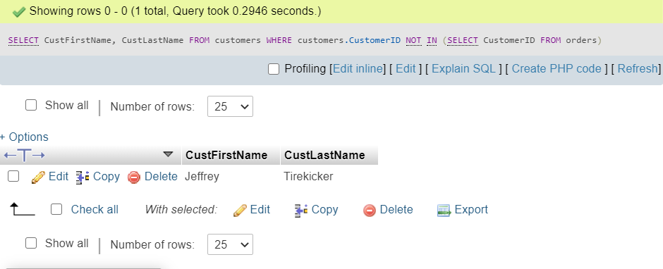

**Another way can be using WHERE NOT EXISTS**

SELECT CustFirstName, CustLastName FROM customers WHERE NOT EXISTS (SELECT CustomerID FROM orders WHERE Customers.customerID = orders.customerID)